LEX PROGRAM:
AIM :
To write a LEX program to identify and print all valid email addresses from the given text file.
LEX PROGRAM :
%{
#include <stdio.h>
%}
%%
[A-Za-z0-9._%+-]+@[A-Za-z0-9.-]+\.[A-Za-z]{2,} {
printf("Valid Email: %s\n", yytext);
}
.|\n ;
%%
int yywrap(void)
{
return 1;
}
int main(int argc, char *argv[])
{
if (argc != 2)
{
printf("Usage: %s input.txt\n", argv[0]);
return 1;
}
FILE *fp = fopen(argv[1], "r");
if (fp == NULL)
{
printf("Error opening file\n");
return 1;
}

yyin = fp;
yylex();
fclose(fp);
return 0;
}
PSEUDO CODE:
BEGIN
OPEN the input text file
WHILE not end of file
READ the next character
IF an email pattern is found THEN
PRINT the valid email address
END IF
END WHILE
CLOSE the input text file
END
ALGORITHM :
- Start the program.
- Read the input text file.
- Scan the file character by character.
- Match email addresses using the regular expression.
- Print each valid email address.
- Stop the program.

INPUT FILES:
Your assignment shows two attachments: email.txt and input.txt.
Create or open input.txt and enter:
Contact: abc@gmail.com
Mail: student123@yahoo.com

OUTPUT IMAGE:
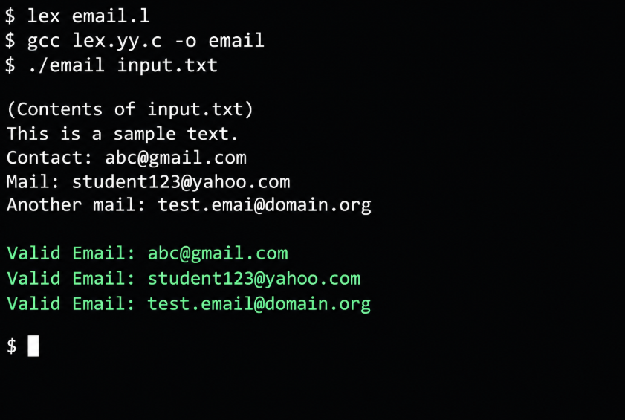
OUTPUT:
Valid Email: abc@gmail.com
Valid Email: student123@yahoo.com
RESULT:
Thus, the LEX program successfully identifies and prints all matching email addresses from the given text file.

